Bethersden Primary School Newsletter

9th February 2024
Dear Parents,

Thank you for all of your support during what has been a brief and busy term! As a school we’ve been focusing on our school value of respect- respecting ourselves, respecting others, and linking respect to diversity. Every time I walk through the school, I am so proud of the way our children demonstrate respect, in how they treat others and their surroundings.

We have lots of news to celebrate this fortnight, and a very busy term coming up. So, I hope you all have a restful and enjoyable half term, and look forward to seeing you all next term.


Headteacher’s Awards
Well done to Shelby, Owen, Freddie, Arlo and Harrison (x2!) in Fox class for climbing our reward chart to the very top- getting a Headteacher Award, and earning 10 points for their houses!
TRA Multi Skills
This week we hosted High Halden, Woodchurch, Wittersham and Rolvenden Primary Schools, for a Multi Skills morning. Under the guidance of Mrs Moss, our Year 6 children did an incredible job of leading the sporting event, by pairing up on each station, to explain the activity, time it, and keep score. Harrison, Owen, Freddie and Arlo also helped to welcome the other children to our school, and take them down to the hall. They did such an amazing job, that a parent from another school sent us this feedback:
I dropped my little boy to your school today for the multi skills competition and I just wanted to say how welcoming it felt.

Not only was your secretary cheery and helpful, but the older children who were also at reception were so well behaved and polite that I felt like it needed to be mentioned.

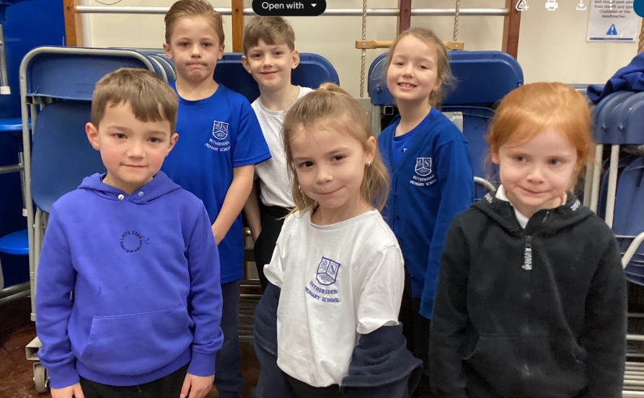
My little boy also really enjoyed the event, so thank you.
Many of the staff from other schools also commented on how polite, kind and helpful the Year 6 team, led by the house captains, in the hall were. Well done Year 6!
A huge well done also to our Year 1 and 2s who were involved- they did a brilliant job of completing the activities and representing the school.
Scholastic Book Fair
We hope children and families have enjoyed the scholastic book fair. £1144.60 of books were sold- sadly we do not receive all of that money, but we will benefit from scholastic vouchers for the school, which we can use to buy more books- thank you all!
Arriving at school on time
A reminder that our school gates shut at 8:40. From next term we will be asking any children who come into school after this are accompanied by their parents into the school office, to complete a late slip.
Diary Dates
Next term is very busy- which means a lot for adults- staff and families- to remember, but so much for children to look forward to!
Key dates are as follows:
Term 4 Diary Dates
School Value of the term is Collaboration.
Week beginning | Events
19th February 2024 | Term begins on Monday 19th February
26th February 2024 | Thursday 29th February- Natural History Museum Trip for Key Stage 2, all children to be in school for 7:30am.
4th March 2024- Book Week | Parent reading afternoons throughout the week  Thursday 7^{th-} World Book Day, dress up as a book character
11th March 2024 | Monday to Friday- Year 6 PGL trip to Windmill Hill
18th March 2024 | Wednesday 20th March Parents’ Evening 2:30-6:00  Thursday 21st March- EYFS Rare Breeds Trip  Friday 22nd March- TTRS and Numbots day- dress up as a Rockstar!
25th March 2024 | Wednesday 27th March ⁻ Badgers class trip- Godinton House  Thursday 28th March- last day of term, children leave at 1:30
Friday 29th March- bank holiday, start of the Easter Holidays!

Water Bottles
From next term we will be ensuring that all children are only drinking water in the classroom, as per my previous email. If your child has been bringing in a different drink, please use the half term as a circuit breaker, and a time to start new habits! As the mother of a very stubborn child who far prefers squash, I know that her nursery having a zero-tolerance approach to other drinks makes my life a lot easier. If all children see and understand that we only have water in our classrooms, it makes it far easier for parents to enforce. Thank you.
Bravo la classe de renards!

Mrs Moss was so proud this week of Year 6’s writing in French- and we were retweeted by Language Angels, our French curriculum provider, who were clearly equally impressed by the high quality of written work.
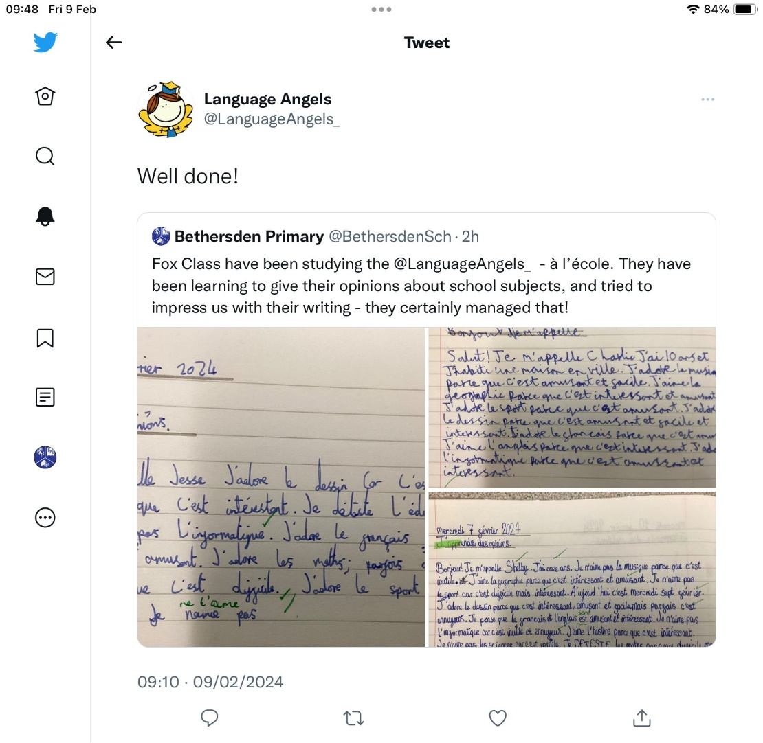

Have a wonderful half term all. It is a well needed rest for everyone, and whilst I am by no means wishing it away, I cannot wait for all of the excitement that Term 4 brings!
Ms Heaton

